

Structural Design

(Inside View)

**Vertical corrugation**

1221*/*32

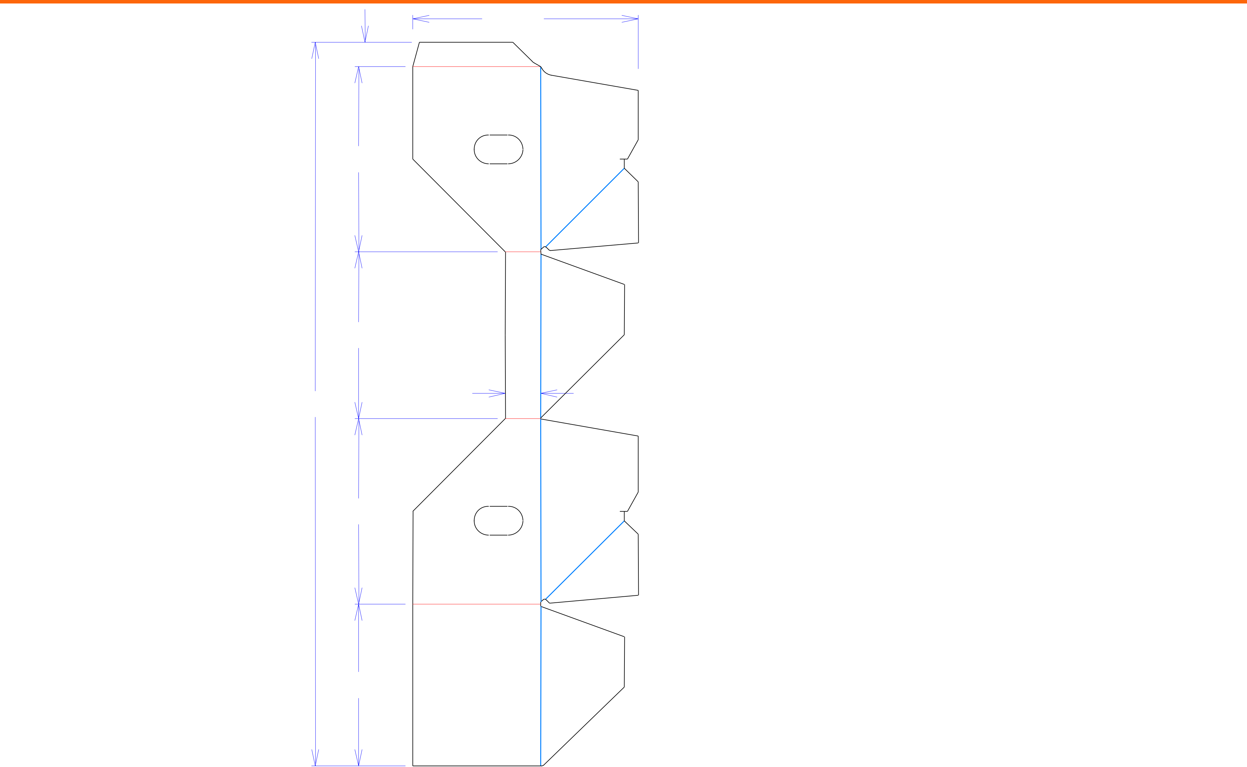

13*/*8

1013*/*32

93*/*8

|  |  |
| --- | --- |
| 4011*/*16 | 2 |

107*/*16

93*/*32

73*/*16

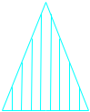

Cut Crease Crease with Matrix Cut Crease Half Knife Cut Tear Tape Perforation



Design#:

**190542-01_A**

Customer:

Description:

**BIB Tray -**

**SINGLE-OUT DRAWING**

Qty/Unit:

Style: **JDC**

Board: **E flute**

Combination: **NA - NA - NA**

I.D. : **10+3/8 x 9+5/16 x 7+1/8**

**O.D.: 101/2 x 97/16 x 71/4**

Area of Blank - Waste : **2.59 sq. ft.**

Waste on Blank : **27.57%**

Finished Piece Weight: **0.01 lbs./2.94g**

Over-all Blank: **40+11/16 x 12+21/32**

**D/C from INSIDE**

**Matrix ALL Scores**

**X= Crush Areas Required**

Notes:

**Poly Joined Item**

Revision Info: **[A] 05/15/2019**

**increase 1/8" AG**

Designer: **Alan Groff**

Designright and Copyright of DS Smith Corrugated Packaging Ltd. This technical Specification is subject to Manufacturing tolerances. Drawing dimensions shown are crease to crease. Date printed: 05/15/2019